Automation Test Report - BlazeDemo Flight Booking Project
Prepared By: Harsh Choudhary
Framework: Selenium + Java + TestNG + Maven + Page Object Model (POM) + ThreadLocal
GitHub Link: https://github.com/Harsh-Panghal/capstone_project
1. Project Overview
This project automates the BlazeDemo Flight Booking application using an Enterprise-Grade Selenium WebDriver framework. Built on the Page Object Model (POM) design pattern, the framework achieves high maintainability and clean separation of concerns. Unlike basic setups, this architecture integrates ThreadLocal memory management for flake-free parallel execution, centralized WaitUtils, and dynamic algorithmic logic for flight selection.
2. Technologies Used
- Core: Java, Selenium WebDriver, TestNG, Maven
- Design Patterns: Page Object Model (POM), Singleton, Factory Pattern
- Data & Configuration: Apache POI (Excel), Java Properties (config.properties)
- Reporting & Logs: ExtentReports, Log4j2
- DevOps: Git, Jenkins Pipeline (Jenkinsfile), Docker (docker-compose)
3. Framework Structure
- base/ (The Engine): Controls TestNG execution lifecycle (BaseTest) and Thread-safe driver sessions (DriverFactory).
- pages/ (The Blueprints): Encapsulates web elements and specific action methodologies using centralized Waits.
- utils/ (The Connectors): Handles external inputs via ExcelReader and ConfigReader.
- listeners/ (The Monitors): Houses TestListener for automated screenshots and RetryAnalyzer for flaky failures.
- tests/ (The Core): Orchestrates positive (E2E) and negative execution suites without hardcoding data.
4. Automated Test Flow
- Launch BlazeDemo Application via Config URL.
- Search Flights dynamically using Excel DataProvider.
- Smart Selection: Algorithmic search scans the WebTable to dynamically select the "Cheapest Flight" instead of a hardcoded row.
- Context Validation: SoftAssert captures runtime data (Airline, Price) from the Results page and matches it on the Purchase page.
- Complete Flight Purchase & Capture unique Booking ID.
5. Test Execution Summary
Test Data (Passenger) | Execution Target | Status | Result (Confirmation ID)
Row 1: Harsh Choudhary | Local Chrome | PASS | Booking Successful (ID: 1781168171964)
Row 2: Aman Singh | Local Chrome | PASS | Booking Successful (ID: 1781168180419)
Row 3: Priya Sharma | Local Chrome | PASS | Booking Successful (ID: 1781168188788)
Execution Metrics:
- Total Test Methods Executed: 12 (4 Steps × 3 Passengers)
- Passed: 12
- Failed: 0
- Skipped: 0
- Pass Percentage (Positive E2E Suite): 100%

6. Execution Log Highlights
- The framework follows an advanced and highly optimized execution pipeline, tracked step-by-step via console outputs and attached to the interactive Extent Report:

- Dynamic Flight Search (Routing Inputs) ➔ Algorithmic Selection (Identifying the Cheapest Flight) ➔ Context Validation (Cross-checking Data Integrity) ➔ Form Submission (Entering Passenger Details) ➔ Booking Confirmation (Capturing unique Ticket ID) ➔ Automated Evidence (Saving Success Proofs to Extent Report) ➔ Test Completed Successfully
7. Defects Identified During Negative Testing
- Critical Authentication Bug (Defect 9): Registration flow throws a "419 Page Expired" preventing new user sign-ups.
- Critical Authentication Bug (Defect 10): Login flow throws a "419 Page Expired" blocking existing users.
- Form Validation Blocker: System successfully confirms flight booking even when passenger details (Name, Address, Card) are submitted completely empty.
- Data Integrity Issue: Confirmation page displays hardcoded dummy data (e.g., Airline: United, Price: 400) instead of the actual selected cheapest flight.

8. Defects Reports and Screenshots
Defact-1
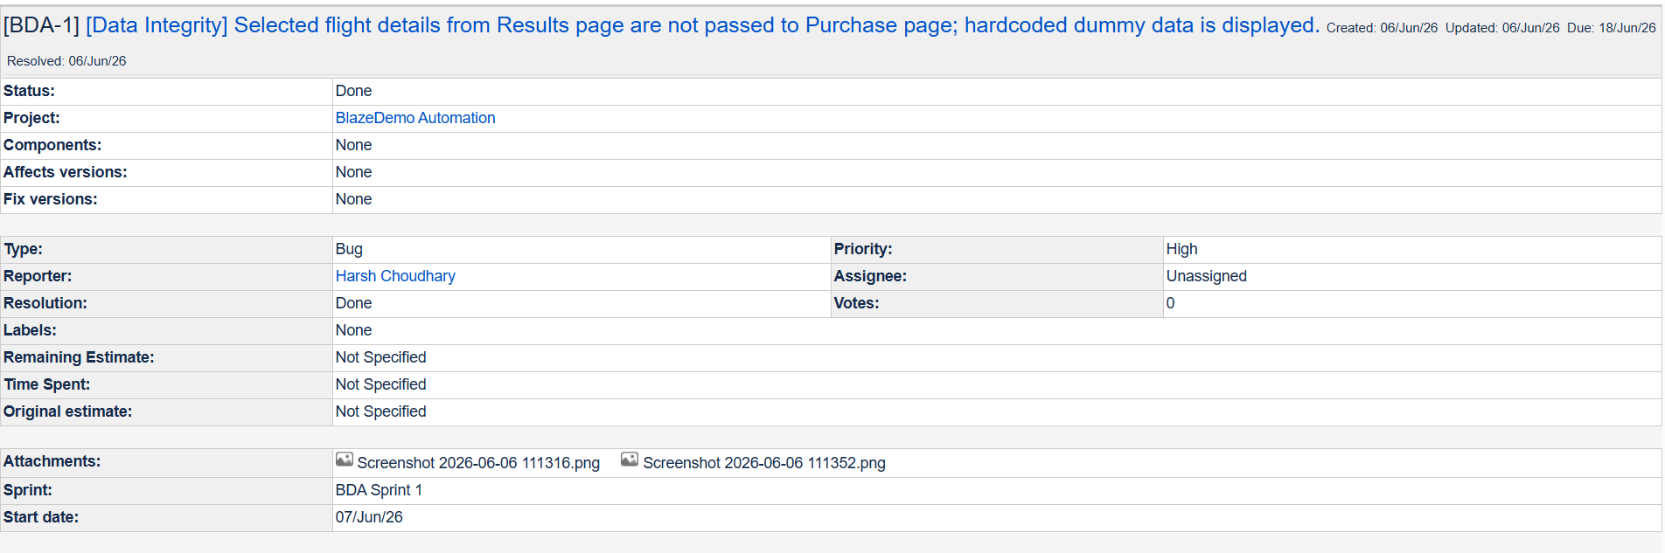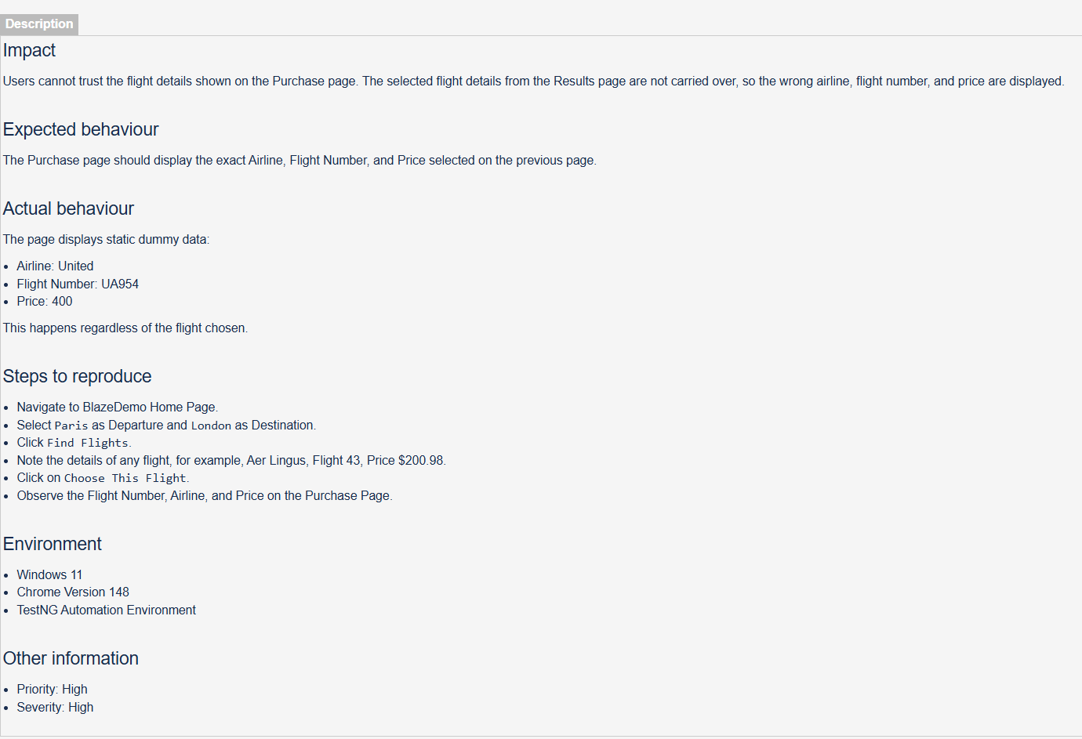

Defact-2
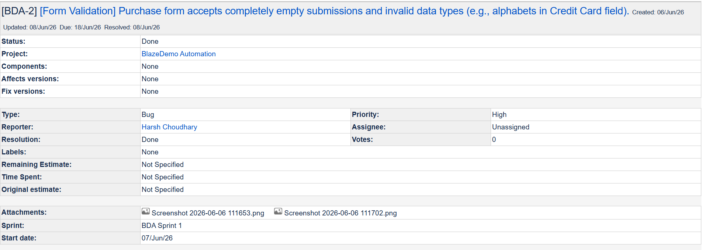
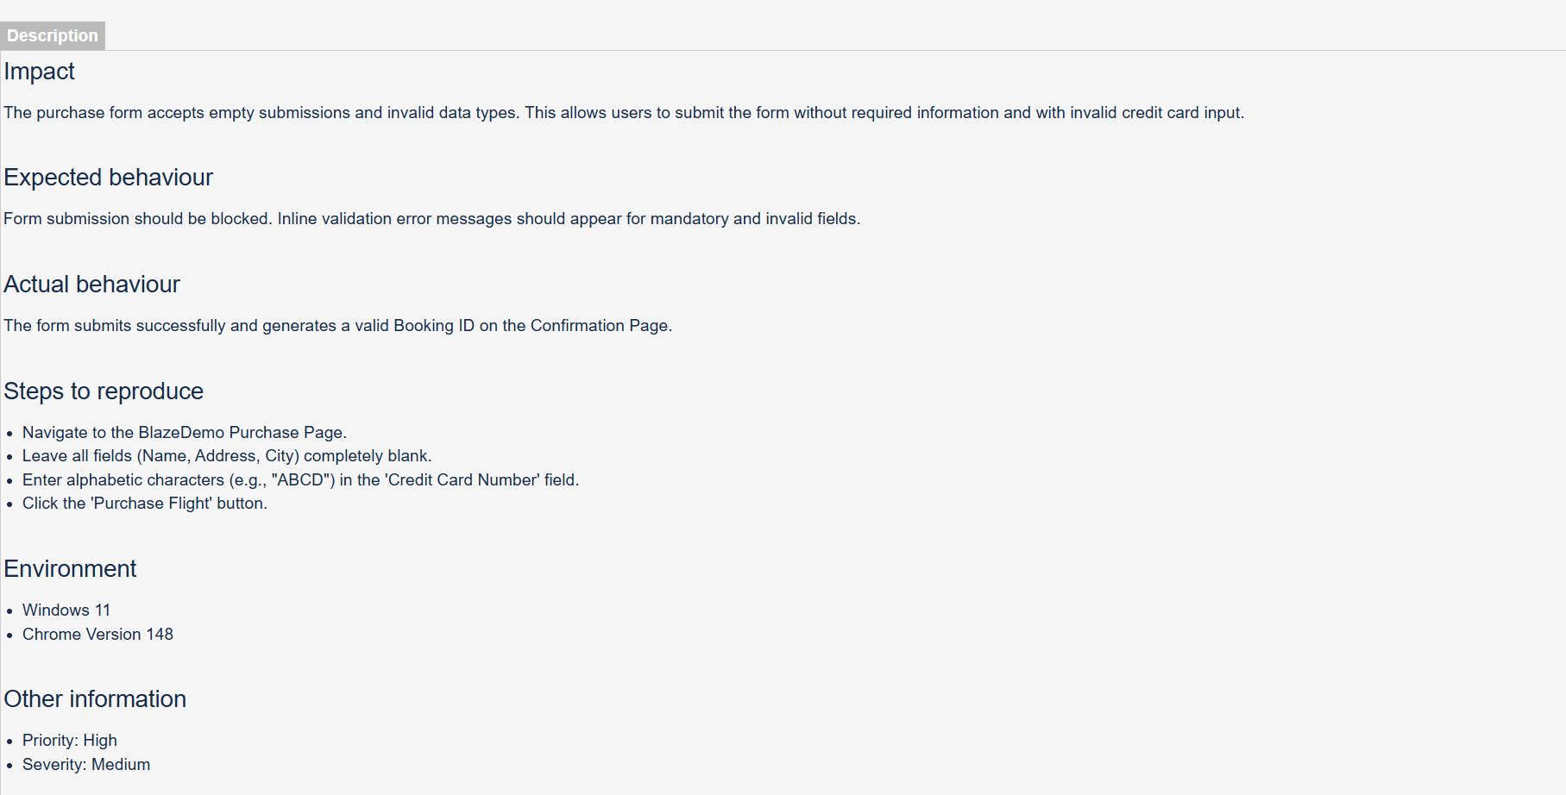

Defact-3
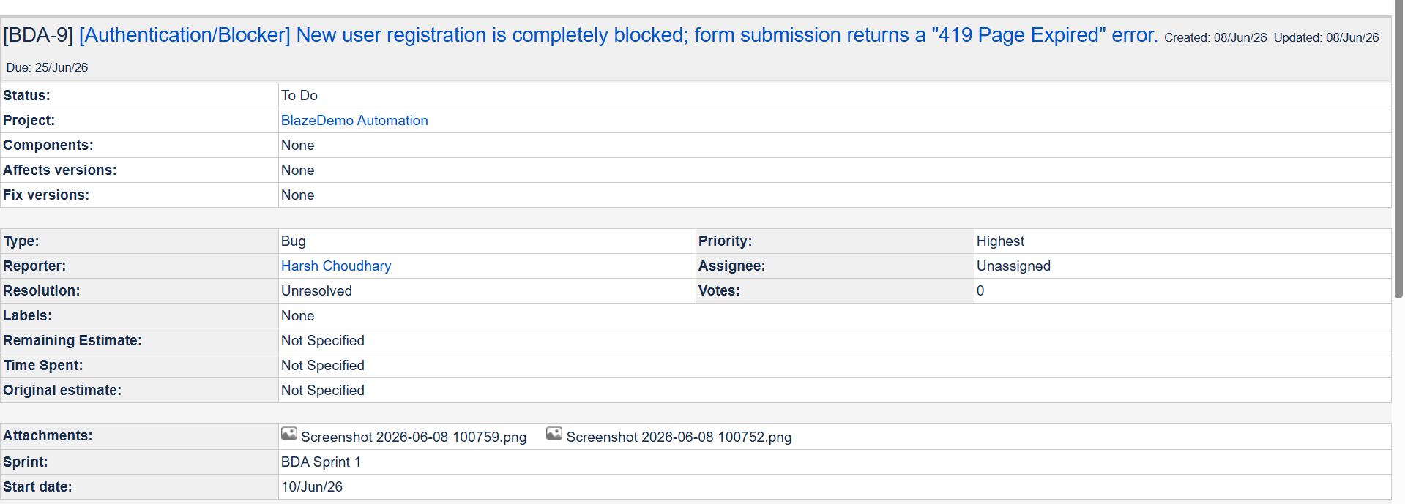
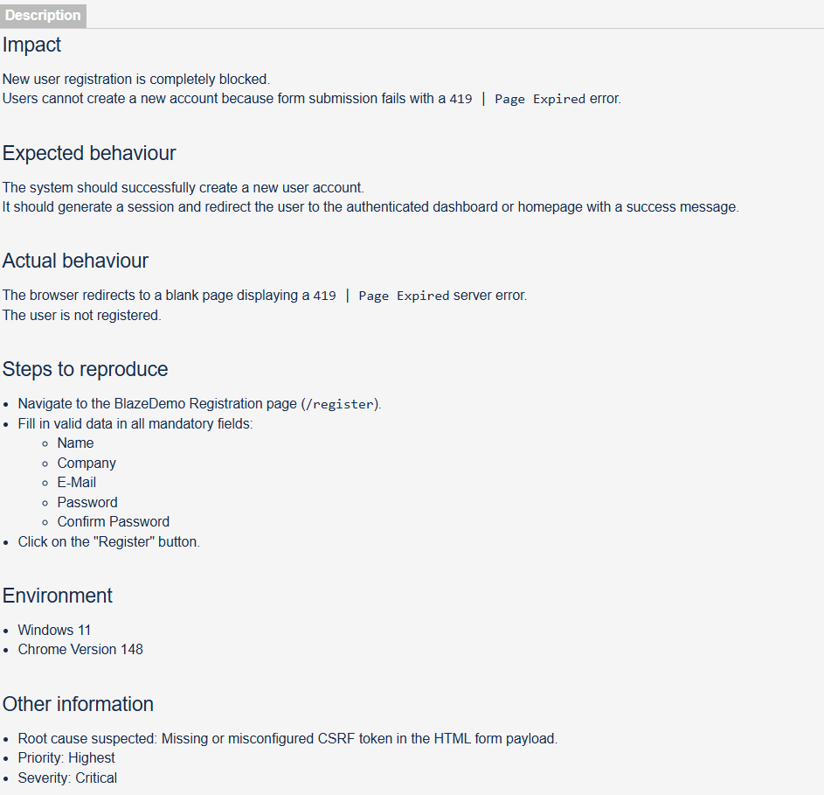

Defact-4
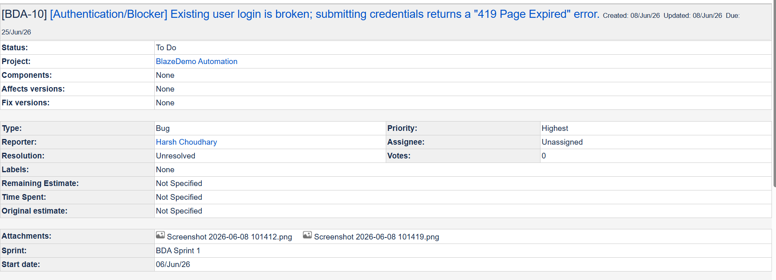
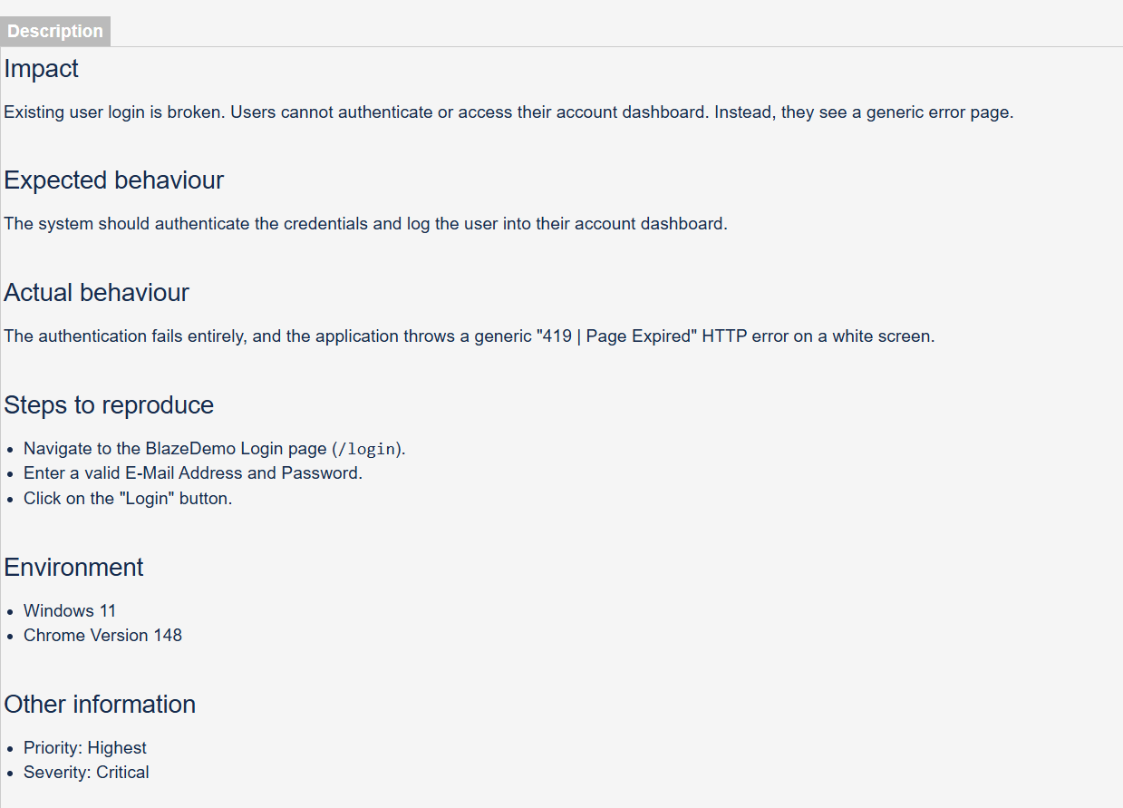

Defact-5
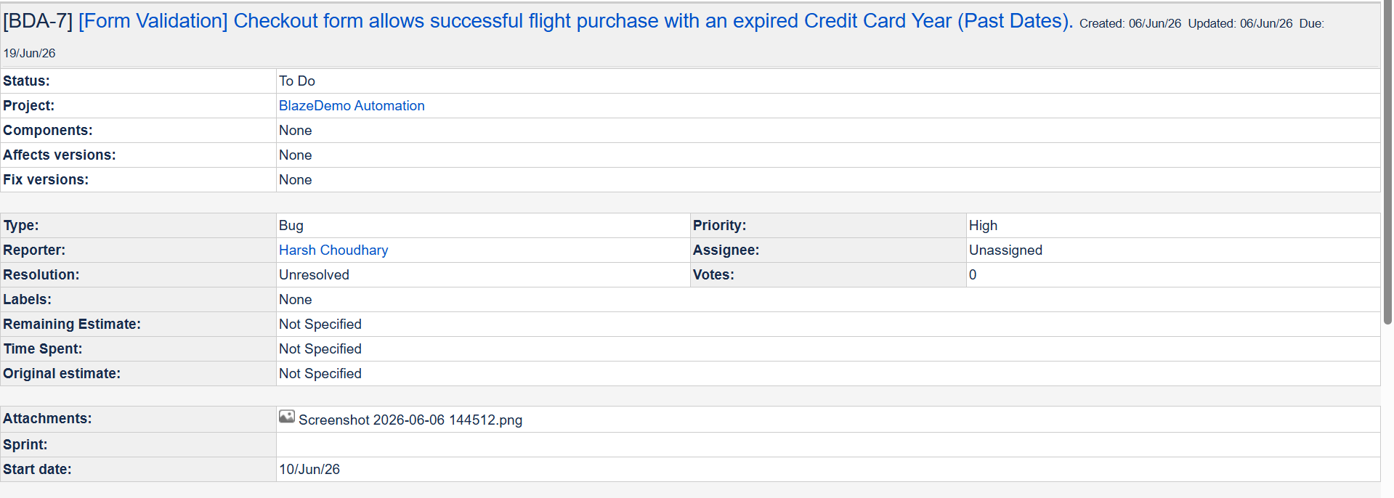

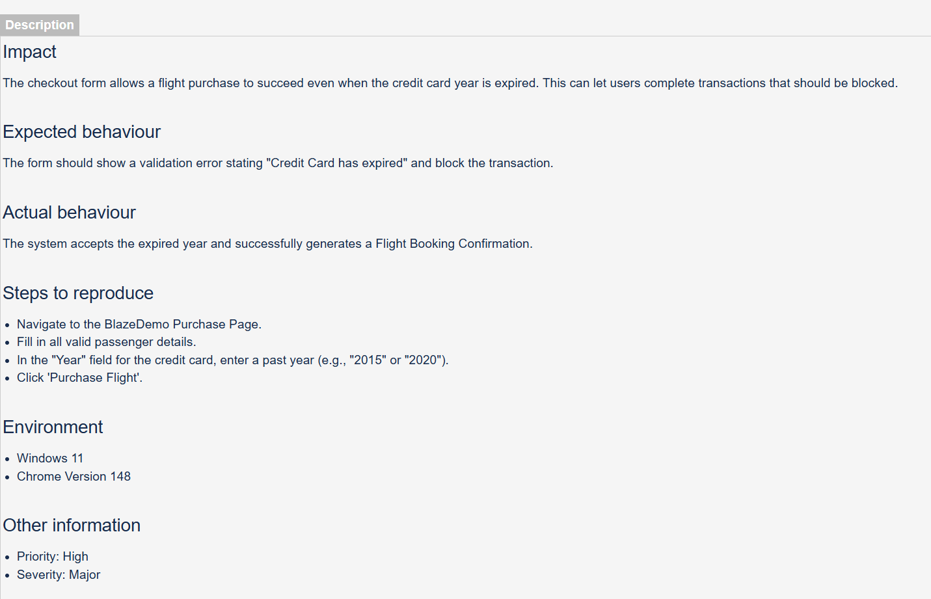

Defact-6
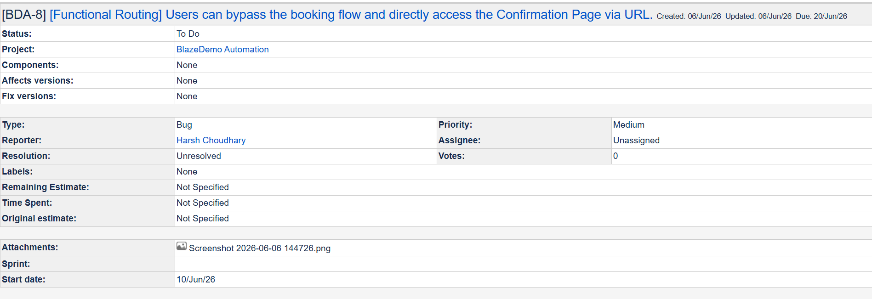
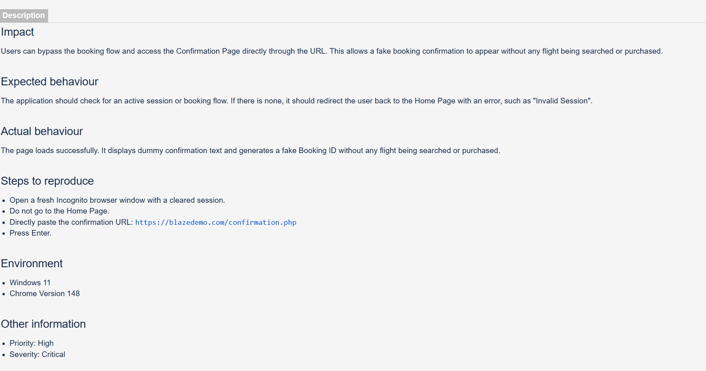

Defact-7
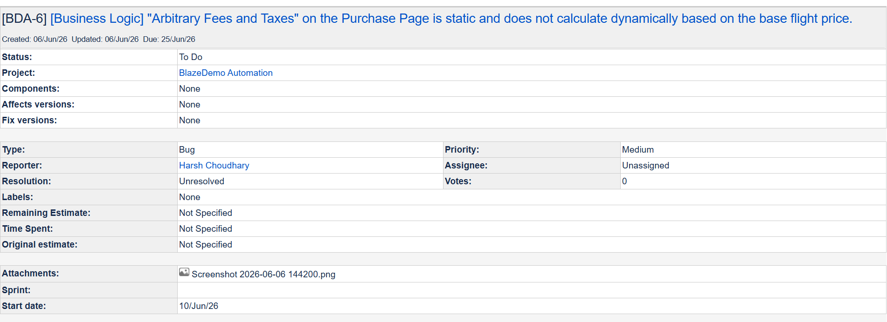
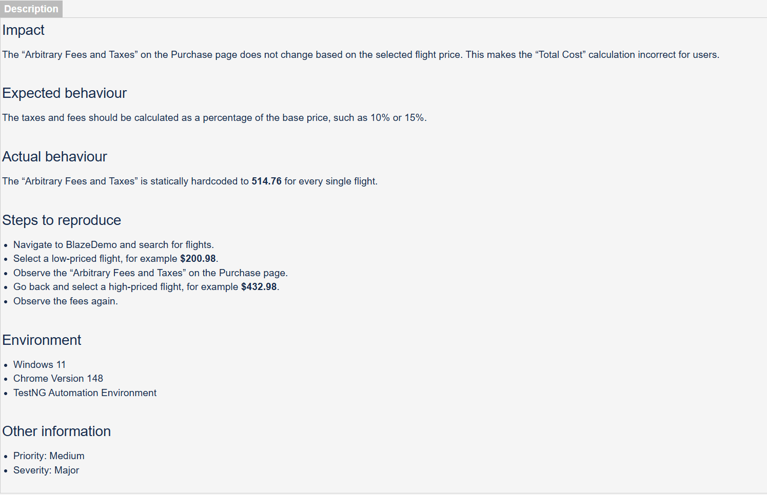

- Defects Summary
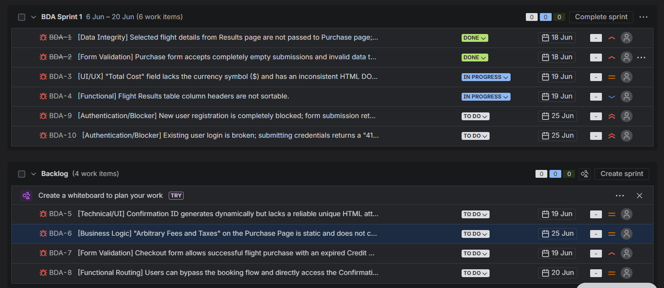

9. CI/CD & Containerization
The framework is completely environment-agnostic.
- Jenkins: Configured a declarative Jenkinsfile pipeline that automatically checks out code, compiles, executes the maven-surefire-plugin (with testFailureIgnore=true), and archives Extent Reports upon completion.

10. Conclusion
The framework successfully executed end-to-end data-driven workflows and captured highly critical security defects via the Negative Testing Suite. By integrating ThreadLocal execution, SoftAssertions, and Dockerized Jenkins pipelines, the architecture proves to be highly scalable and production-ready.

